EXP. NO: 9
PERFORMANCE EVALUATION OF AM GENERATION AND DETECTION UNDER NOISY CHANNEL CONDITIONS USING MATLAB
MATHLAB CODE:

clc;
clear;
close all;
% Parameters
fs = 100000;
t = 0:1/fs:0.02;
fm = 500;
fc = 5000;
% Message Signal
m = cos(2*pi*fm*t);
c = cos(2*pi*fc*t);
% AM Modulation
am = (1 + m).*cos(2*pi*fc*t);
% Add AWGN Noise
noisy = awgn(am,10,'measured'); % 10 dB SNR
% Envelope Detection
env = abs(hilbert(noisy));
% Display Results
figure;
subplot(5,1,1)
plot(t,m)
title('Message Signal')
grid on
subplot(5,1,2)
plot(t,c)
title('Carrier Signal')

grid on
subplot(5,1,3)
plot(t,am)
title('AM Signal')
grid on
subplot(5,1,4)
plot(t,noisy)
title('AM Signal with AWGN Noise')
grid on
subplot(5,1,5)
plot(t,env)
title('Recovered Signal')
grid on

WAVEFORM:

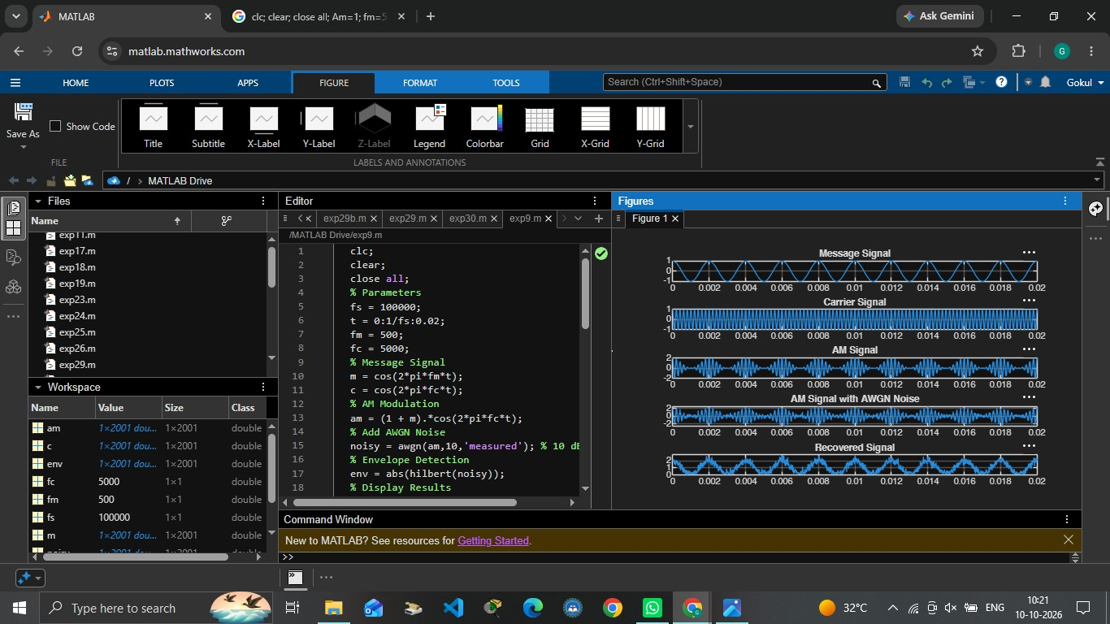

OUTPUT:

